**AUTOMATIC TREE PLANTING ROBOT**

1Sumit Prajapati, 2Shubham Rai, 3Milind Mali, 4Manish Kumar, 5Abhishek Kumar

1BE Final Year Student of Electrical Engineering

1Laxmi Institute of Technology, Sarigam-Bhilad, India

______________________________________________________________________________________________________­­­

***Abstract***: An automatic tree planting robot should be suitable for all kinds of tree plantation work and it should also be reliable and efficient, which is the basic requirement for our project. The main motto of our project is to reduce the man power needed to plant trees. Nowadays humans are too busy with their work that they do not have time to plant trees, in such case we would see a lot of reduction in trees in the near future. So, we thought of implementing a tree planting robot which would reduce the reduction of trees to a great extent. From this we can plant different types of saplings. We have tried to make it cheap by using different process method so that it becomes affordable to one and all. We have made its control very easy so that it does not get difficult for the users.

***Keyword****:* **tree planting, seed sowing, agriculture, robot, automation, horticulture, planting, gardening, agronomy.**

**_________________________________________________________________________________________________________________**

**I. INTRODUCTION**

Ever imagined a robot that will plant trees? But now this could be possible with the help of this project. Yes, an automated robot that would plant trees. In order to restore the ecosystem this is the solution that can help to maintain sustainability of the environment. But this work is very tedious and tiring so mankind/human beings should turn to tree planting robots.

Ever wondered what if – this entire work just needed a single person. So, we gave it a thought and came up with the idea of tree planting robot. New technologies emerge each and every day to make our lives simpler and easier. The process targets locations where we need to plant trees and sow seeds. Also, we have the flexibility to alter what and where to plant. In a way this robot can plant a greater number of trees in very less time compared to human beings.

Agriculture is the backbone for India and still the people are using the traditional methods instead of the new and better options. Agriculture is primary source of income and employment for many people in India. But still there are very few technological advancements in the main farming and planting process. Still ploughing and sowing are done manually or by Tractor by the people of India. So, this project introduces new advancement/technology to help the people i.e., related to plantation and agriculture.

This technology is especially designed and developed to help the people in reducing their back-breaking efforts while doing the agricultural and planting activities. We need to restore the trees so the it covers basically a huge amount of region in India, but at this rate it looks very scary. That’s why we need to improvise and adopt the innovations. When people learn how to give back to the land, the land gives them back. So, it’s very essential to plant trees for a better tomorrow. Basically, this robot has one mission that is to plant trees for a better future. Here is the block diagram of the model along with its working. It also includes the hardware implementation, selection of components and controllers. It is basically a four-wheeled robot which will be very helpful in tree planting and seed sowing.

**II. OBJECTIVE OF ROBOT**

This robot has a very moderate cost so that it can be easily afforded by the people. This is smartly controlled and we have implemented very simple controlling so that unskilled people can also operate it with ease. This robot is powered by a battery and it gets started when it gets the command form the operator via., Bluetooth Module & performs a check if everything is ok. After the starting command is given digging bit come at position by dc gear motor, then the digging bit comes down by the help of limit switch & the motor for digging is turned on. Similarly, the digging bit comes up by the help of limit switch after digging the ground. Now, sliding pipe come at position by dc gear motor & plant magazine move one position & then it checks if the sampling is available or not. If the magazine is empty the robot stops and alarm is ON. If sampling is there then sliding pipe move down by the help of limit switch, after the sampling is planted the sliding pipe move upward by the help of limit switch & soil press mechanism is turned ON. Finally, the robot moves to next position (as per set revolution). If obstacle arrives it stops and alarm is ON.

**III. LITERATURE REVIEW**

**3.1 SEED SOWING ROBOT**

The main aim of this is the automatic way of sowing the seeds. The seeds are been sowed in a proper sequence which results in proper germination of seeds. This automatic way of sowing seeds using a robot reduces the labour requirement. Here the wastage of seeds is also been reduced to a greater extent. This system has been developed for the sowing of seeds in an automatic way. Here with the help of a robot the seeds are been dispensed in the soil in a proper sequence thereby reducing the wastage of seeds. The planting process of the onion crop only has been implemented by using this Seed Sowing V robot autonomously. This robot will help the farmers to do the farming process efficiently. The project can be enhanced to any other kinds of crop such as fruits, paddy, sugarcane etc. The robot can be designed with chain roller instead of normal wheel. Hence, it can be applicable to the real time agricultural field. But the accuracy of this robot could reduce due to cold, mod and hard areas. It mainly consists of PIC microcontroller, DC motors with driver, solenoid valve, relay and its driver. The microcontroller is programmed using the Proload software which accepts the C language.

**3.2 DESIGN AND FABRICATION OF SEED SOWING MACHINE**

The design of the seed sowing machine is simple and the components used for making this are having moderate cost, only the sensors cost a bit. Drive shaft is used for metering mechanism instead of pulleys and belt/conveyer system which reduces the cost. The shaft is driven by DC motor which is coupled with the battery bank. As the motor starts it moves this robot as well as operates the metering mechanism. Seed storage tank is connected at the top of the robot near rear wheels. The sensor is fitted to it which senses the level of seed in it and gives the alarm when the tank is empty. Front sensor serves the function of guiding the robot. As any obstacle comes in front of robot it gives the signal to the robot and diverts the path of robot. For every rotation of the wheel according to the adjustment it allows the definite seed to fall into the hoper so that there is no wastage of the seeds also the sowing process is smooth. When the robot reaches at other end and when it completes task it creates an alarm so that another task can be done. This could have been much better if automation would have been there. It is operated manually and would require frequent maintenance. Metering needs to be proper in order to achieve efficiency & to avoid loss or wastage of seeds. It consists of a structural frame, battery powered wheels, seed storage tank, seed sowing disc, seed bucket, seed chamber, & plough.

**3.3 DESIGN AND DEVELOPMENGT OF MANUALLY OPERATED SEED PLANTER MACHINE**

The basic requirements for small scale cropping machines are, they should be suitable for small farms, simple in design and technology and versatile for use in different farm operations. A manually operated template row planter was designed and developed to improve planting efficiency and reduce the tediousness involved in manual planting method. Seed planting is also possible for different size of seed at variable depth and space between two seed. Also, its increased seed planting, seed/fertilizer placement accuracies and it was made of durable and cheap material affordable for the small-scale peasant farmers. The operating, adjusting and maintaining principles were made simple for effective handling by unskilled operators (farmers).

**IV. PROPOSED METHODOLOGY**

The proposed methodology for this current project involves the flowchart and block diagram of the present work. The following are as given below.

Figure 4.1: Flowchart

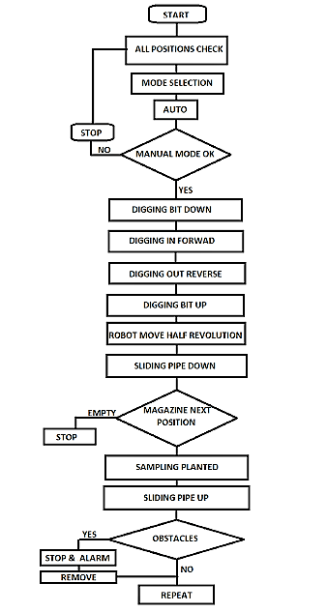

**4.1 FLOWCHART EXPLANATION**

1] Start power ON, then the robot waits for the starting command from the operator via. Bluetooth & performs a check if everything is ok.

2] After the starting command is given digging bit come at position by dc gear motor, then the digging bit comes down by the help of limit switch & the motor for digging is turned on.

3] Similarly the digging bit comes up by the help of limit switch after digging the ground.

4] Now, sliding pipe come at position by dc gear motor & plant magazine move one position & then it checks if the sampling is available or not. If the magazine is empty the robot stops and alarm is ON

5] If sampling is there then sliding pipe move down by the help of limit switch, after the sampling is planted the sliding pipe move upward by the help of limit switch & soil press mechanism is turned ON.

6] Finally the robot moves to next position (as per set revolution). If obstacle arrives it stops and alarm is ON.

**4.2 BLOCK DIAGRAM**

**4.2.1 Explanation of block diagram**

**H- Bridge Drive (L293D) –** Here we have used this along with the motors to switch the polarity.

* 2 DC Gear Motor High Torque (30 RPM) for forward and reverse movements of the wheel.
* 2 DC Gear Motor Low Torque (30 RPM) for slide pipe & digging bit up & down purpose.

**Limit Switch -** Here we have used a total of four limit switches.

* Two limit switches for sliding pipe up & down
* Two limit switches for digging bit up & down

**Voltage Regulator –** Here we have used a voltage regulator to regulate the voltage. IC 7805 is used which gives a constant 5V output to the required sensors. The block diagram is shown in the figure below:

Figure 4.2: Block Diagram

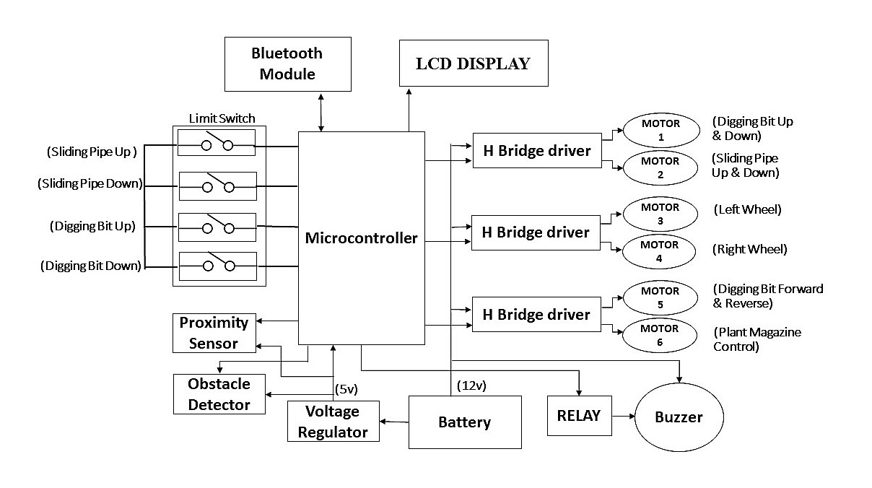

**4.3 WORKING**

Start power ON, then the robot waits for the starting command from the operator via. Bluetooth. & performs a check if everything is ok. After the starting command is given digging bit come at position by dc gear motor, then the digging bit comes down by the help of limit switch & the motor for digging is turned on. Similarly, the digging bit comes up by the help of limit switch after digging the ground. Now, sliding pipe come at position by dc gear motor & plant magazine move one position & then it checks if the sampling is available or not. If the magazine is empty the robot stops and alarm is ON. If sampling is there then sliding pipe move down by the help of limit switch, after the sampling is planted the sliding pipe move upward by the help of limit switch & soil press mechanism is turned ON. Finally, the robot moves to next position (as per set revolution). If obstacle arrives it stops and alarm is ON.

**4.4 COMPONENTS**

Table 4.1: List of Components

|  |
| --- |
| 1. Drilling Bit |
| 2. Frame/Chassis |
| 3. Relay Module |
| 4. H-Bridge Drive (L293D) |
| 5. Arduino Mega |
| 6. Battery 12V, 1.3 Ah |
| 7. PCB |
| 8. IR Proximity Sensor |
| 9. Drawer Channel |
| 10. Sliding Pipe |
| 11. Limit switches |
| 12. Display 16*2 |
| 13. Buzzer |
| 14. Magazine/Sampling Holder |
| 15. DC Gear Motor (Low Torque) |
| 16. DC Gear Motor (High Torque) |
| 17. HC-05 Bluetooth Module |
| 18. Inductive Proximity Sensor |
| 19. Voltage Regulator (IC 7805) |
| 20. Rack & Pinion Mechanism |

**4.5 HARDWARE IMPLEMENTATION**

Figure 4.4: Actual Model Image 1

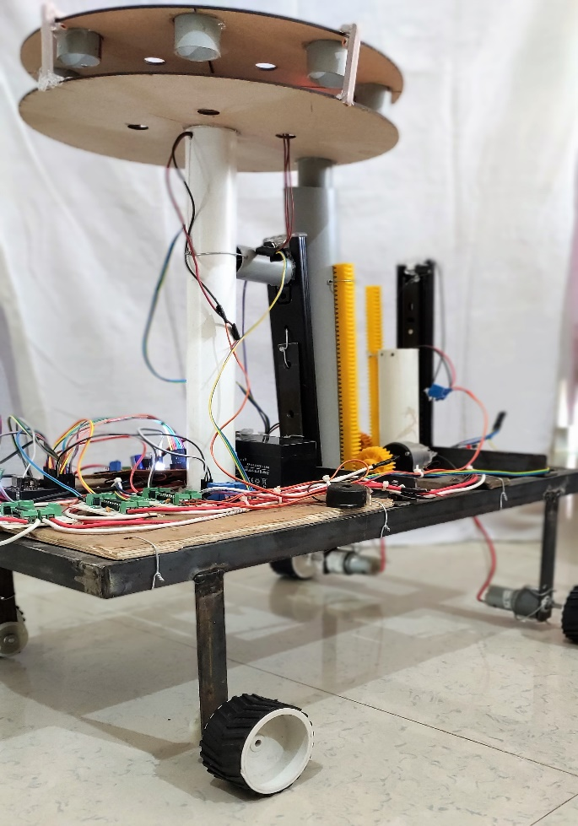

Figure 4.5: Actual Model Image 2

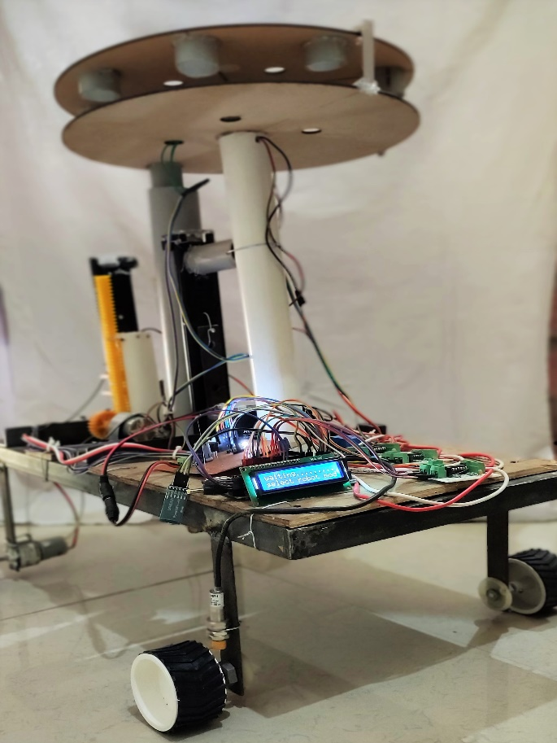

**4.6 SOFTWARE SPECIFICATION**

The open source Arduino software (IDE) makes it easy to write code and upload it on the board. It runs on Windows, Mac OS & Linux. This software can be used with any Arduino board. The [Arduino](https://en.wikipedia.org/wiki/Arduino) Integrated Development Environment ([IDE](https://en.wikipedia.org/wiki/Integrated_development_environment)) is a [cross platform](https://en.wikipedia.org/wiki/Cross-platform) application(for [Windows](https://en.wikipedia.org/wiki/Windows), [macOS](https://en.wikipedia.org/wiki/MacOS), [Linux](https://en.wikipedia.org/wiki/Linux)) that is written in functions from [C](https://en.wikipedia.org/wiki/C_(programming_language)) and [C++](https://en.wikipedia.org/wiki/C%2B%2B_(programming_language)).. It is used to write and upload programs to Arduino compatible boards, but also, with the help of 3rd party cores, other vendor development boards. Arduino is an open-source electronics platform based on easy-to-use hardware and software. [Arduino boards](https://www.arduino.cc/en/Main/Products) are able to read inputs - light on a sensor, a finger on a button, or a Twitter message - and turn it into an output - activating a motor, turning on an LED, publishing something online. You can tell your board what to do by sending a set of instructions to the microcontroller on the board. To do so you use the Arduino programming language (based on wiring), & the Arduino software (IDE), based on processing.

**V. MERITS**

1. It will reduce the manpower/labour required to plant trees

2. Only a single person can operate this

3. Easy control (via., smartphone)

4. Time saving

5. The back-breaking work of the labours can be reduced

6. Beneficial to farmers in sowing seeds in their farm more easily, efficiently and effortlessly

7. Cheap/economic

8. Long-life

9. Can be easily made

10. Portability

11. Convenient and flexible

12. Pollution free

13. Do not require skilled person

14. Negligible maintenance

15. Efficient fast farming and tree plantation

16. Good Accuracy

17. This can help to improve the efficiency of plantation

18. Durable and economic as the materials are less costly

**5.1 APPLICATIONS**

1. Farming

2. Gardening

3. Plantation

4. Forest

5. Agriculture Universities

**VI. CONCLUSION**

This project will help to overcome some problems in agriculture and forest department as this could be a very useful device to work easily, efficiently and effortlessly & it will also help in save the time. The operation of this robot is very simple & easy & it does not require any skilled person for its operation. As compared to manual operation it could result in less wastage. Also, energy required for this is less compared to manual operation. So, this device will be a better option for the people indulged in agricultural & forestry activities. It can also be manufactured by any local workshop. The main task now is to promote these kinds of technologies & making it available to the consumers easily and at an affordable cost. So, we think that this project is a boon to the modern world and it has something good to serve and it should be taken into consideration. We hope that this device will help in reducing the difficulties of reforestation & shortage of labour.

**6.2] FUTURE SCOPE**

We have made an attempt to make this model & other modification can be made to this if this device is taken into consideration and worked upon. Efforts can be made to add a water feeding unit along with tree planting and seed sowing mechanism. Solar panels can also be added to make it more effective.

**REFRENCES**

1] Patrick Piper and Jacob Vogel published a paper on “Designing an Autonomous Soil Monitoring Ro-bot” (IEEE - 2015).

2] V.M. Martin Vimal1, A. Madesh1, S. Karthick, A. Kannan, “Design and Fabrication of Multipurpose Sowing Machine”, International Journal of Scientific Engineering and Applied Science (IJSEAS), ISSN: 2395-3470, Volume-1, Issue-5, August 2015.

3] Thorat Swapnil V, Madhu L. Kasturi, Patil Girish V, Patil RajkumarN International Research Journal of Engineering and Technology (IRJET) Volume 04 Issue 09, 2017

4] Abdulrahman, Mangesh Koli, Umesh Kori, Ahmadakbar at International Journal of Computer Science Trends and Technology (IJCST) – Volume 5 Issue 2, Mar – Apr 2017

5] Istiven Appavoo, Anicet Marionneau, Michel Berducat, Benoit Merckx, Natacha Olivier, Loic Cotten at SATT Grand Centre Irstea (National Research Institute of Science and Technology for environment and Agriculture) 3 Alliance Forets Bois.

6] Research and development in agriculture robotics: a perspective of digital farming by Redmond Ramin Shamshiri, Cornelia Weltzien, Ibrahim A. Hameed, Ian J. Yule, Tony E. Grift, Siva K. Balasundram, Lenka Pitonakova, Desa Ahmad, Girish Chowdhary (International Journal of Agriculture and Biological Engineering).

7] Dhaval Patel, Ani Kyadaauto, 5th International & 26th All India Manufacturing Technology, Design and Research Conference (AIMTDR 2014) December 12th–14th, 2014, IIT Guwahati, Assam, India.